**trace.DES function improvement**

Simple 3-state Partitioned Survival model in Rs

Time recorded in seconds

n_i = 10,000

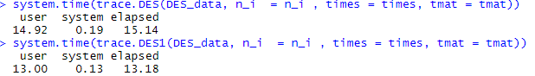

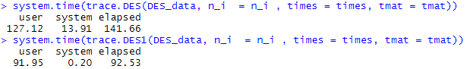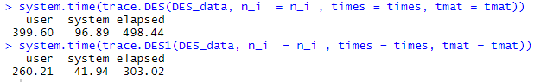n_i = 50,000

n_i = 100,000

n_i = 150,000

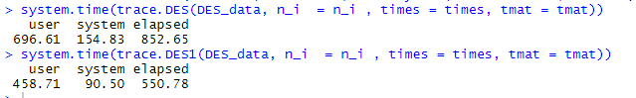

n_i = 200,000

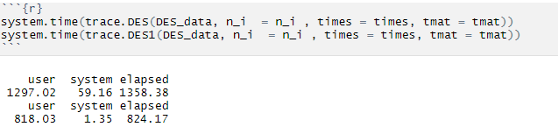

n_i = 300,000

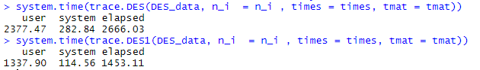

n_i = 500,000

